NOTICE OF PUBLIC MEETING

HARRIS COUNTY EMERGENCY SERVICES DISTRICT NO. 11

Notice is hereby given pursuant to the Texas Government Code, Chapter 551, as amended, that the Board of Commissioners (the "Board") of Harris County Emergency Services District No. 11 (the "District") will meet in regular session, open to the public, at 5:00 p.m., Tuesday,

November 18, 2025, at the District's Administration Building, 18334 Stuebner Airline Road, Spring, Texas 77379, a location within the District, at which the subject of and matters to be considered and acted upon will include the following:
- Call meeting to order and moment of silence for prayer and reflection;
- Public comments (2 minute limit per person or 5 minute limit per subject, whichever is less);
- Presentation of Service and Meritorious Awards;
- Approve the minutes of the October 28, 2025 regular meeting;
- Confirm engagement of auditor for Fiscal Year Ending December 31, 2025; 6. Chief Executive Officer's ("CEO") Report, including:
  - review compliance, clinical, IT, fleet, public relations, safety, HR and operations matters;
  - review and approve Amended and Restated Lease Agreement with Harris County
Emergency Services District No. 13; and
  - review and approve Amended and Restated Interlocal Agreement with Harris County Emergency Services District No. 7;
- Chief Financial Officer's Report, including:
  - approve payment of bills and issuance of checks; and
  - review Investment Report;
- Discuss property, liability, workers' compensation and cyber liability insurance renewal through Gallagher, as necessary (expires December 31st);
- Discuss 2026 employee insurance/benefits, and take any necessary actions on same; 10. Tax Assessor/Collector's Report; 11. Attorney's Report, including:
  - review recent Public Information Act or subpoena requests and status of responses to same, if any; and
  - annual review of District Covered Application Prohibition Policy;
- District real estate matters, including status of request for qualifications for engineering services in connection with the potential sale of remainder of administrative property;
- District personnel matters, including any pending employment related claims, and take any necessary actions on same;
- Executive Session pursuant to Chapter 551, Texas Government Code, ("Open Meetings Act") to discuss District matters, as may be necessary; and
- Adjournment.
The Board of Commissioners is authorized by the Open Meetings Act ("OMA") to convene in closed or Executive Session for certain purposes. These purposes include: receiving legal advice from its attorney(s) pursuant to §551.071, Texas Government Code; discussing real property
4933-4242-8538, v. 1

matters pursuant to §551.072, Texas Government Code; discussing gifts and donations pursuant to §551.073, Texas Government Code; discussing personnel matters pursuant to §551.074, Texas Government Code; discussing security personnel or devices pursuant to §551.076 and §551.089, Texas Government Code; and discussing cybersecurity and critical infrastructure pursuant to §551.0761, Texas Government Code. If the Board decides to enter into Executive Session regarding any item on this agenda, the Presiding Officer will announce that an Executive 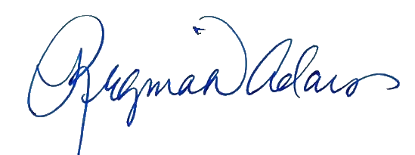authorizes the closed or Executive Session.
S
ession will be held and will identify the item to be discussed and provision of the
OMA

that
E
XECUTED this
13
th

day of

November
,

202
5
.

(
DISTRICT SEAL
)

Regina D. Adams

Radcliffe Adams
Barner

PLLC

General Counsel
for the District

4933-4242-8538, v. 1

